**SETTING UP APPLICATION ENVIRONMENT CREATE SEND GRID ACCOUNT**

|  |  |
| --- | --- |
| **Date** | **18 November 2022** |
| **Team ID** | **PNT2022TMID32892** |
| **Project Name** | **Project – The News Tracker Application** |

**Step 1:**

Go to official Sendgrid website: https://sendgrid.com/then click start for free

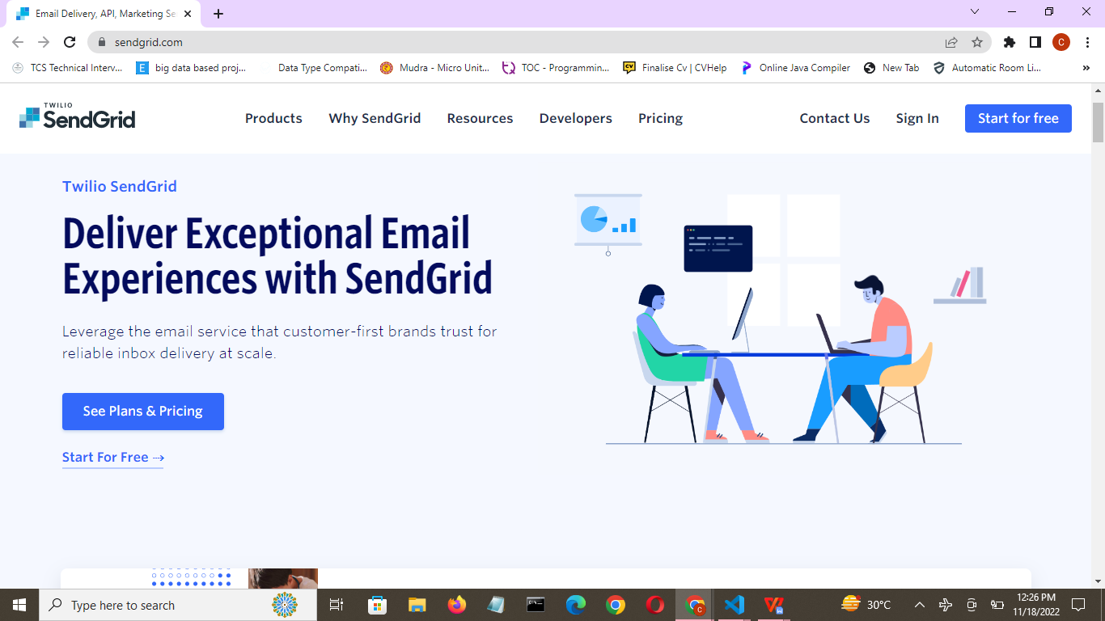

**Step 2:**

Then go to Registration Page, you need to give all the details required for creating a Sendgrid account and finally click create button. The below screenshot will show the registration Process.

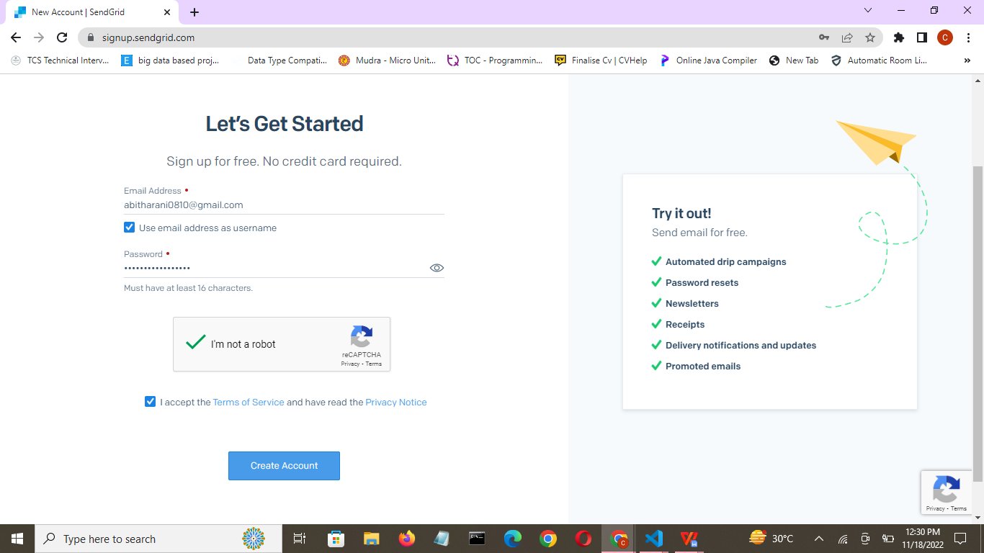

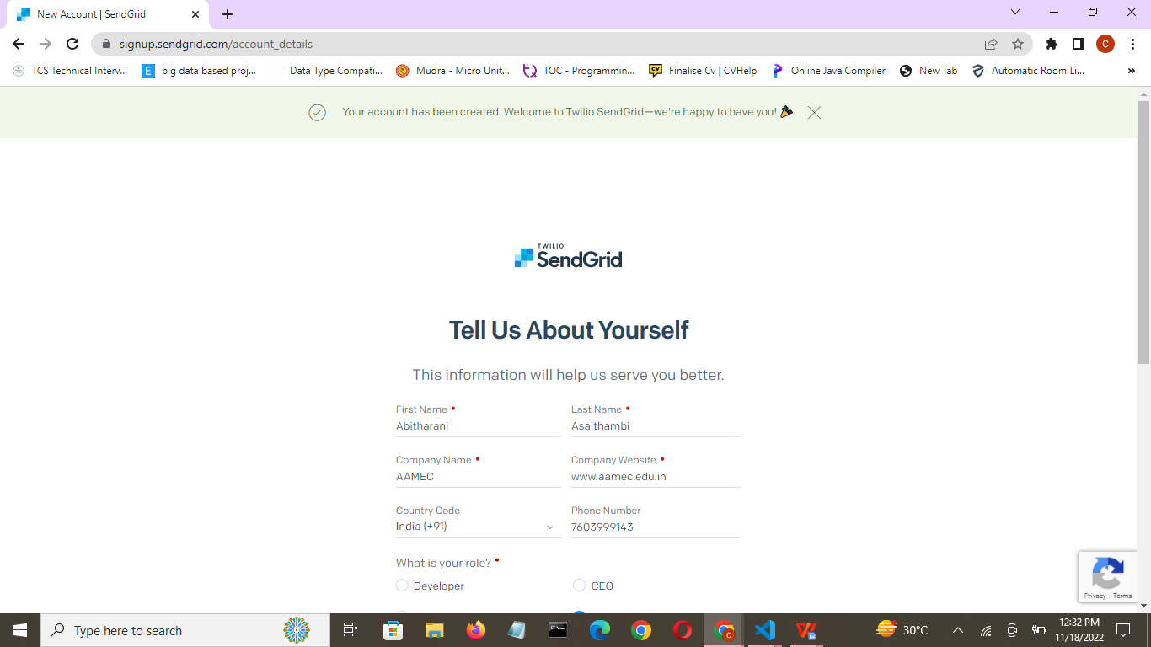

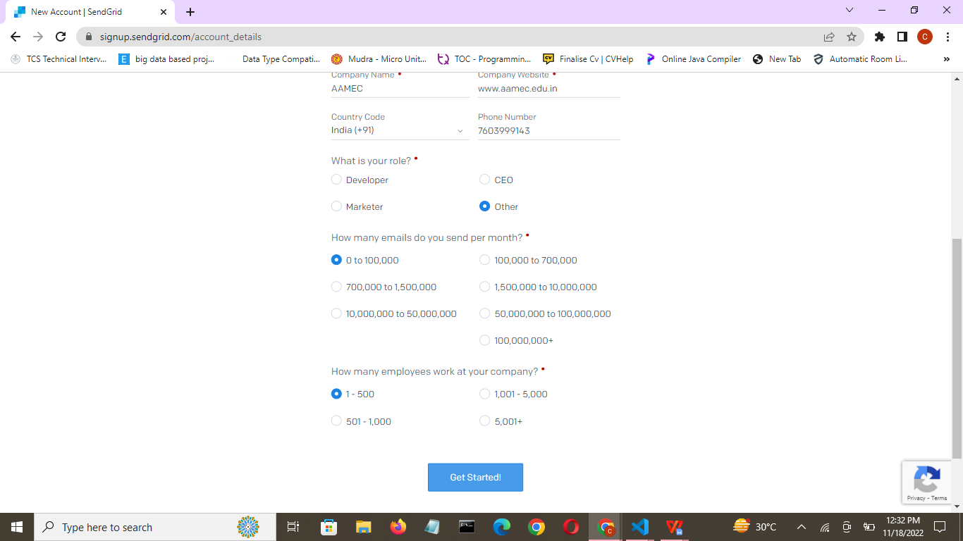

**Step 3:**

Then it will redirect you to a home page of your sendgrid account

